Architecture Design

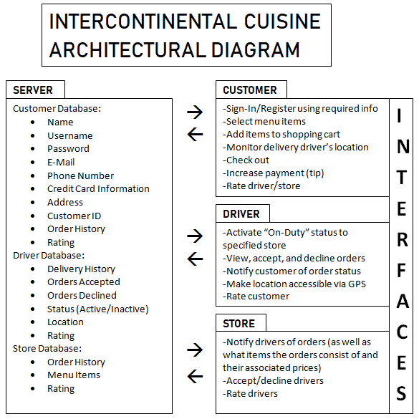

Java will be used for the mobile apps using android studio and for the web service using eclipse and java EE. Mysql will be used for the databases.